# 

# 2015 Design for Change

# *Video Brief*!

The Design for Change USA Challenge calls for every team to put together a short **3-5 minute** *homemade* video that captures the essence of their community change project and the impact (even in the short term) that it has on the intended audience (community). Videos MUST include each of the elements described below in order to be considered for the grand prize – an opportunity for 5 members of your team to participate in the Design for Change Global Conference (Mexico). See glimpses of past DFC Global Conferences – [Be The Change](btc.dfcworld.com)!

**All submissions are due by May 15, 2015**.

Teams must submit their videos directly to designforchange.us

**Example Video Crazy Horse, Pine Ridge Reservation, South Dakota**

https://www.youtube.com/watch?v=x5a6OtnohmU&feature=youtu.be

[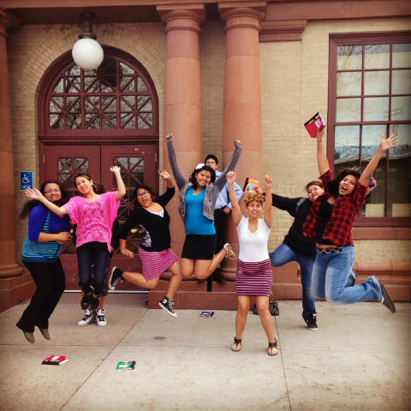](https://www.youtube.com/watch?v=x5a6OtnohmU&feature=youtu.be)

## Overview

* Your DFC USA video submission should tell the story of how you went through the **Feel, Imagine, Do, Share** process to design an implement your social change project

## Structure and Format

* The video should be no more than **3-5** minutes long
* Please send us as high resolution video
* Format your video using the following headings: **Feel, Imagine, Do, Share**
* Include not only your success, but also the challenges you faced and how you overcame them

## Things to Keep in Mind

* At each stage of the Design for Change process, you should:
  + Film and interview your team brainstorming and implementing their ideas
  + Film and interview any or all mentors/educators involved with the project
  + Film and interview any or all members of the community affected by the project
* Ask the all people participating in the video to speak clearly, loudly, and with their natural enthusiasm
* Ask all participants to paraphrase the question into their answer
  + e.g., when asked “why are you participating in DFC? The response should be “I am participating in DFC because…”
* Keep your background in mind, have a fun lively background but ensure it is not distracting
* Consider incorporating DFC slogans, “I AM THE CHANGE” or “I CAN” or “FEEL, IMAGINE, DO, SHARE”

## Specific Shot List

* Young people in action executing their projects, in their element, having fun
* Close up of organization/school, specifically the exterior of the building including a sign with the organization/school name
* Close up of materials being used by the young people for their projects
* Interaction between young people and mentor/teachers/peers/community
* Young people saying “I AM THE CHANGE”, “I CAN”, “YES WE CAN”, “FEEL, IMAGINE, DO, SHARE

## Questions for Interviews

### Students/Young People

* What is the name of your school/organization? What is the name of your community or city?
* Who are you? What is your name, age, and grade?
* What does Design for Change mean to you? Why are you participating? What do you feel about the Feel, Imagine, Do, Share process?
* What is your big idea to create change in your community? Tell us about your project? Why did you pick the problem you did? Why is this problem important to you?
* How are you executing your solution?
* What impact did you make? What impact do you hope to make?

### Mentor/Teacher

* What is the name of the school/organization? What is the name of the community or city?
* Who are you? What is your name, what is your role with the team (staff/mentor)?
* What does Design for Change mean to you?
* **(If staff)** Why did you want your students/young people to participate in DFC? What have your students/young people learned/gained by participating in DFC and using the DFC process?
* What have you gained by participating in DFC?
* What message do you have for other organizations/schools as to why they should participate?